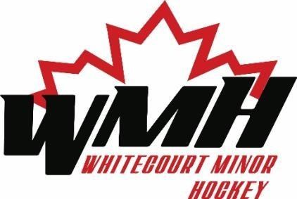
Whitecourt Minor Hockey Association

Date September 11, 2019

Revised Date: October 30, 2019

Policy Apparel

Purpose To set direction for ordering/purchasing Off Ice Apparel

- All off ice apparel includes tracksuits, jackets, hoodies, dryland gear, toques and hats. Player names (first or last or combo) only on all tracksuits, jackets, and hoodies will be located on the left bicep horizontally. Player names (first or last or combo) on dryland gear will be located front left leg and back middle collar below brand name. Player’s numbers for toques and hats on back. Each team can choose to put the player’s number on track suits and dryland gear and it will be located beneath the name if it is chosen.

- WMH will provide an apparel catalogue in which all clothing will be ordered from. Prior to any on ice sessions WMHA will have apparel catalogue available for the membership. There will be a High/Mid/Low brand options based on both price point and quality so that each team can make that decision. Any apparel that is not part of WMHA catalogue must be brought to the board prior to purchase for approval. If it is approved your team would be able to use the WMHA logo as per this policy.

- The use of the wolverine’s logo as per guidelines/pictures set out in the apparel catalogue. The logo cannot be altered or reproduced without expressed written consent of the WMHA board. These restrictions are in place to ensure consistency throughout the association. As per the vote on May 2021 we will be using the WMH logo for apparel moving forward. If a team or individuals would like apparel with the wolverines logo it can be purchased through the Wolverines Team store.

- There will be no division identification on any apparel.

- There must be no corporate logos or company names on team attire to minimize conflicts that occur between sponsors. There will be a maximum of 2 corporate names (no logos) allowed on track suits if the companies meet the standards below.

- If 2 companies are splitting the costs of providing track suits to an entire team.
- The location for Company names would be on the right bicep using the same size and coloring as the name on the left side.

- WMHA has the right to deny approval to any request of ordering apparel outside of our catalogue. disallow of any apparel that does not follow the policy set out.

- Teams not adhering to these dress code regulations may be sanctioned at the discretion of the WMH executive and board of directors. At which point would be brought to the discipline committee for a decision. The penalty for not following the above policy would be up to $2500 fine.

- All WMHA Executive decisions are final. Any decision made by WMH executive and discipline committee can be appealed. Please refer to the appeal policy for details and process.

